**545/2 CHEMISTRY**

**SECTION A**

**1. Identify a suitable method to separate the substances in the mixtures below.**   **(1 mark @)**

1. Vanila oil from Vanila seeds.

Solvent extraction

1. Ammonium carbonate and Lead(II)sulphate.

Filtration

1. Methylbenzene and Xylene.

Fractional distillation

1. Water and Carbontetrachloride.

Separating funnel

1. Silvernitrate and sodiumethanoate.

Fractional crystallization

**2. 3.0g of an alloy of copper and Zinc was reacted with excess dilute hydrochloric acid and 840cm3of hydrogen gas was given off measured at s.t.p.**

1. **State the name given to the mixture of Zinc and copper. (Mark)**

Brass

1. **Write equation for the reaction that occurs. (1mark)**

Zn (s) + 2 HCl (aq) ZnCL2(aq) +H2(g)

1. **Calculate**
2. **Mass of copper in the alloy. (2 marks)**

**(Cu=64, Zn=65, Molar gas Volume at s.t.p is 22.4l)**

Moles of H2

22400cm3 contains 1 mole of H2

840cm3 contains mole of H2

= 0.0375 moles

1 mole of H2 produced by 1 mole of Zn

Mass of Zinc

1 mole of Zinc contains 65g

0.0375 moles of Zinc contains (65 x 0.0375)g = 2.44g

Mass of copper = (3.0 – 2.44) g

= 0.56g

1. **Percentage of copper in the alloy. (1 mark)**

% of copper in the alloy = 0.56/3 x 100

= 18.67%

**3(a) Define the term “Atomic number”. (1 mark)**

The number of protons in the nucleus of an atom

(b) In XCl2, Y (NO3)2, Z3PO4 and QO2

X, Y, Z and Q belong to periods 3, 4, 1 and 2 respectively in the Periodic Table. X, Y are metals while Z and Q are non- metals.

1. **Write the possible electronic configuration of Y & Q (1 mark @)**

Y: 2:8:8:2

Q: 2:4

1. 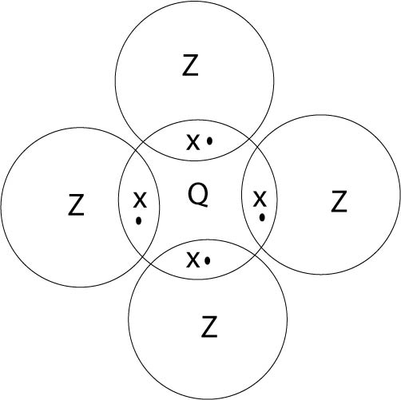**Use Valence electrons only to show the structure formed between Z and Q**   **(2marks)**
2. **State the two properties of the structure formed in b (ii). (mark @)**

(i) It has low building / melting point

(ii) It does not conduct electricity

(iii) It is a gas at room temperature

**4. (a) When dry ammonia gas was passed over 3.2g of anhydrous copper (II) sulphate, 4.9g of solid**

**CuSO4. PNH3, was formed.**

**Find the value of P. (3 ½ marks)**

Mass of pNH3 is (4.9 – 3.2 ) g

= 1.7g

CuSO4(s) + pNH3(aq) CuSO4. pNH3(s)

R.F.M of CuSO4= 64 + 32 + 16 x4 = 160

Moles of CuSO4 = = 0.02 moles

1 mole of CuSO4 reacts with 1 mole of pNH3

0.02 moles of pNH3 contain 1.7g

1 mole of pNH3 contains = 85

(14 +3) p = 85

P = 5

**(b)Then excess aqueous ammonia again was added to the solution of the solid above. State the observation. (1 ½ mark)**

Pale blue ppt soluble in excess to form a deep blue solution.

**5. Both ammonium phosphate and Calcium Phosphate can be used as fertilizers.**

**(a) What is a fertilizer?** **(1mark)**

A substance that improves soil fertility

**(b) Calculate the percentage of phosphorus in**

(Ca=40, p=31, O=16, N=14, H=1)

Ammonium Phosphate. (1 ½ mark)

(i) (NH4)3 PO4

% of P = 31/((3 x 14+12+31+16x4)) x 100

= 31/149 x 100

= 20.8%

(ii) Calcium Phosphate. (1 ½ mark)

Ca3(PO4)2

% of P = (31 x 2)/((40 x 3+31 x2+16 x8))

= 62/230 x 100

= 26.05%

**(c) Which of the two substances is a better phosphate fertiliser? Give a reason for your answer.** Calcium phosphate, with a high percentage composition of phosphorus **(1 mark**

**6. Sodiumhydroxide solution was added to a mixture of solutions of sulphates of Magnesium and Zinc dropwise until in excess, the mixture was then filtered.**

a) Identify.

**(i) The ion in the filtrate. (1 mark)**

Zinc ion or Zn2+

**(ii) The compound in the residue. (1 mark)**

Magnesium Hydroxide (Mg(OH)2)

**(b) Explain the observations in a (i) and (ii). (include relevant equations) (03 marks)**

Zinc ions form a white ppt soluble in excess sodium hydroxide solution are amphoteric

Magnesium ions form a white ppt insoluble in excess sodium hydroxide solution.

Magnesium ions in their solution are not amphoterial basic

**7. With equations for the reactions below, state the role of the acid on each of the following substances.**

**(a) Concentrated nitric acid on copper. (02 marks)**

EquationCu(s) + HNO3(aq)CU(NO3)2(aq) + NO (g) + H2O(l)

Role: As a oxidizing agent

**(b) Concentrated Hydrochloric acid on Manganese (IV) oxide. (2 marks)**

Equation: MnO(s) + HCL(aq) MnCL2(aq) + CL2(g) + H2O(l)

Role: As a reducing agent

**8(a) Explain the term “*Molar enthalpy of Combustion***” (1 mark)

Heat given out when one mole of a substance completely burn in air

**(b) The equation below shows combustion of charcoal.**

C(s) + O2(g)→ CO2(g) DH=-12.5KJ mol¯1.

**(i)Calculate the mass of charcoal burning to form to 5000Joules. (1 ½ mark)**

12500J produced by 12g of charcoal

5000J produced by x 5000J of charcoal

= 4.8g of charcoal

1. **Calculate the cost of 6kg of charcoal. If the cost of using 12.5KJ of charcoal is 20/=. (1 ½ mark)**

12g of charcoal costs 20/=

6000g of charcoal costs (20/12 x 6000) /=

= 10,000/=

**9(a) Sodium carbonate crystals were left exposed in the air for some days.**

1. **State what was observed** (mark)

White powder

1. **Write equation for the reaction that took place**. (1 ½ mark)

Na2CO3. 10H2O(s) Na2CO3(s) + 10H2O (l)

**(b) An aqueous solution of sodium carbonate was added to magnesium nitrate solution.**

**(i) State what would be observed. (½ mark)**

White ppt

**(ii) Write equation for the reaction. (1 ½ mark)**

Na2CO3(aq) + MgSO4(aq) Na2SO4(aq) + MgCO3(aq)

**(c) (i) State what would be observed when dilute nitric acid was added to the product of the reaction in b(i). (1 ½ mark).**

White solid dissolves to a colourless solution with bubbles of a colourless gas that turns lime water milky.

1. **Write an equation for the reaction in c (i) above.**

+ Mg (NO3)2(aq) +CO2g+H2O *(l)*

**10(a) A mixture of Magnesium powder and Lead (II oxide heated strongly until there was no further change.**

1. **State what was observed. (1 ½ mark)**

A yellow powder turns white

1. **Write the equation for the reaction that took place. (1 ½ mark)**

PbO(s) + Mg(s) MgO(s) + Pb(s)

**(b) The experiment in (a) was repeated using a mixture of copper turnings and Magnesium oxide. State what was observed. (½ mark)**

No observable change

**(c) Briefly explain your observation in (a) and (b) above. (1 ½ mark).**

Magnesium is more reactive than lead, it displaces reduce it from oxides as in (a) above.

Copper is less reactive than magnesium, it does not reduces, the oxide of magnesium as in (b)

**SECTION B**

**11(a) Explain briefly the effect of litmus solution on the following (your answer should include equation for the reaction where possible.) (7 ½ marks)**

1. **Ammonium sulphate.**

Litmus solution turns red, a solution of ammonium sulpahte in water is acidic

(NH4)2 SO4(s) + 2H2O(l) 2NH4OH(aq) + H2SO4(aq)

Ammonium sulpahte is formed from a strong acid and a weak base

1. **Ammonium carbonate**

The colour of litmus solution is not affected /Neutral a solution of ammonium carbonate in water is neutral

(NH4)2 CO3(s) + 2 H2O(l) 2NH4OH(aq) + H2CO3(aq)

Ammonium carbonate is formed from a weak acid and a weak base

1. **Potassium carbonate**

Litmus solution turns blue a solution of potassium carbonate in water is basic

K2CO3(s) + 2H2O (l) 2KOH (aq) + H2CO3 (aq)

Potassium carbonate is formed from a strong base and a weak acid

**(b) Chlorine reacts with the following substances.**  **(7 ½ marks)**

**(i) Potassiumbromide**

A brown solution is formed (chlorine displaces bromine)

2KBr(aq) + CL2(aq)  2KCL(aq) + Br2(l)

**(ii) Iron (II) sulphate solution.**

Chlorine oxidizes Iron (II) ions to Iron (III) ions

Fe2+(aq) Fe3+(aq) + e

**(iii) Dye.**

Chlorine bleaches the dye

CL2(g) + H2O(l) + Dye (Dye + O) + HCL(aq)

**(c) State the role of chlorine in each of the reactions above and give a relevant equation for the reaction where possible.**

12. Study the reaction scheme shown below and answer the questions that follow.

Glucose

Polyethene

Ethanol

Ethene

Ethane

Ethanol

1

3

5

2

4

1. **State the type of reactions(1-5)**

Reaction 1 is Fermentation

Reaction 2 is Dehydration

Reaction 3 is Polymerization

Reaction 4 is Hydration

Reaction 5 is Hydrogenation

1. **State the reagent in 4 and 5.**

The other reactant in 4 is water

The other reactant in 5 is Hydrogen gas

1. **(i) Write the equations for the reactions in 1, 2 and 5.**

C2H6O(l) (conc H_(2〖SO〗_4 ))/(Heat 〖170〗^(0 C - 〖180〗^0 C) ) C2H4(g) + H2O(l)

Equation for 5

C2H4(g) + H2(g) Ni/〖150〗^0C C2H6(g)

1. **Ethanol on its complete combustion produced a gaseous product at room temperature. The gaseous product was passed through the following samples of solutions separately.**
2. **Calciumhydroxide solution in excess**

White ppt soluble with excess bubbling of carbondioxide to form a colourless solution. On Bubbling of little carbondioxide into calcium Hydroxide solution, calcim carbonate as an insoluble salt is formed as a white ppt the ppt is soluble in excess carbondioxide as calcium hydrogen carbonate a soluble salt is formed as a colourless solution

Ca(OH)2(aq) + CO2(g) + H2O(l) Ca(HCO3)2 (aq)

1. **Sodiumhydroxide solution in excess.**

colourless solution formed first with excess bubbling of carbondioxide, a white ppt is formed sodium carbonate, a soluble salt is formed as a colourless solution first, with excess bubbling of carbondioxide, sodium Hydrogen carbonate an insoluble salt is formed as white ppt

2NaOH (aq) + CO2(g) Na2CO3(aq) + H2O(l)

Na2CO3(aq) + CO2(g) + H2O(l) 2NaHCO3(s)

State and explain your observations in d(i) and d(ii) above. **(6 marks)**

1. **State an application of the property in d (i) above. (1 mark)**

**It is the laboratory test for carbondioxide gas**

**13(a) Explain the term “Electrolyte**” **(1 mark)**

Substance in its molten or aqueous state conducts current and chemically decomposes.

**(b) Copper strips were lowered into a solution of copper (II) sulphate and then to the external source of current.**

**(i) State the factor determining the products in the process in (b) above. (1 mark)**

Nature of the electrodes

**(ii) Explain your observation in the process in (b) above (diagram required).**

At the anode

The anode dissolves into the copper solid turns into copper ions

Cu(s) Cu2+(aq) + 2e

At cathode

The cathode size increases the copper ions are discharged to copper

Cu2+(aq) + 2 e Cu(s)

The colour (blue) of the solution does not change **(4 marks)**

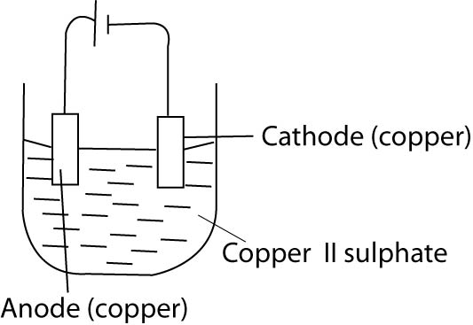

**(c) Describe briefly how Iron can be extracted from one of its suitable ore (Diagram not required)**

From Haemitite (Fe2O3. AH2O)

The ore is roasted in air to remove impurities such as water, sulphur dioxide.

The ore, lime stone and coke are fed into a blast furnace

The air in the furnace oxidizes coke to carbon monoxide

2Cu(s) + O2(g) 2CO(g)

Carbon monoxide reduces the oxide to Iron

2Fe2O3(s) + 2CO(g) 4Fe(s) + 2CO2(g)

Heat in the furnace decompose lime stone to calcium oxide

CaCO3(g) CaO(s) + CO2(g) + Heat

Calcium oxide removes silicon dioxide as impurity in form of slag

CaO(s) + SiO2(s)CaSiO3(l) slag

**(9 marks)**

**14(a) Explain the term *solubility of a salt.*** **(1 mark)**

Amount of a solute that dissolves in 100g of a solvent/water to form a saturated solution

(b) The table below shows the solubilities of salts P, Q and R at different temperature. Study the table and answer the questions that follow.

|  |  |  |  |  |  |
| --- | --- | --- | --- | --- | --- |
| Temperature(oc) | 0 | 5 | 8 | 10 | 15 |
| Solubility(g/100g of water of |  |  |  |  |  |
| P | 15.0 | 22.9 | 33.0 | 50.0 | 85.1 |
| Q | 24.9 | 29.0 | 32.9 | 37.1 | 48.0 |
| R | 35.1 | 33.1 | 33.1 | 34.1 | 37.9 |

1. On the same axes, Plot graph of solubility against temperature for the data above.

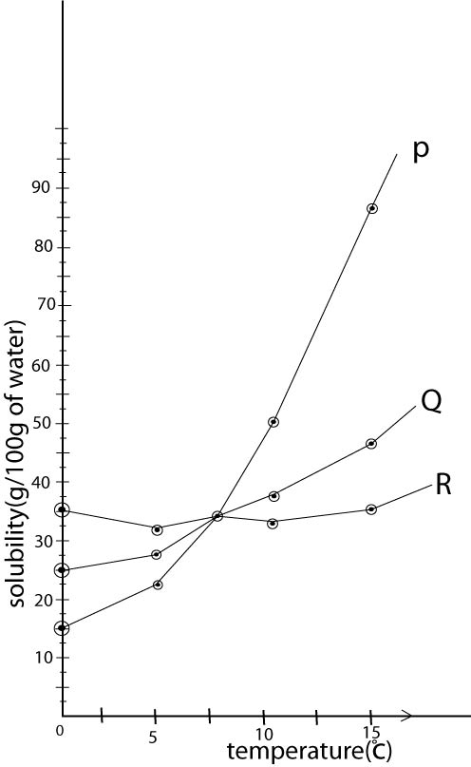**(7 marks)**

1. Given that P, Q and R are salts of sodium. Which of the salt is a

* Carbonate?
* Nitrate?
* Sulphate?

**(c)(i) Describe laboratory preparation of sodiumSulphate crystals from Sodium hydroxide solution.**

Pipette a known volume of sodium hydroxide solution into a clean conical flask. Add 2-3 drops of phenolphthalein indicator.

Run a solution of dilute Sulphuric acid of a known concentration from the burette in the conical flask for the colour of the solution to immediately change.

Transfer the solution in the flask into an evaporating dish; evaporate the solution to be saturated.

Crystal of the salt (whites) form/cool the solution to obtain the white crystals.

2NaOH(aq) + H2SO4(aq) Na2SO4(aq) + 2H2O(l) **(4 ½ marks)**

**(ii) Identify the type of reaction taking place in c (i) above. (1 mark)**

Neutralisation **END**